**BEEE LAB EVALUATION**

**Report**

**Ques: Design a visitor counting system using LDR of a hall.Assume that only one person can pass through door at any time and also there are separate entry and exit doors .**

**Circuit Diagram:**

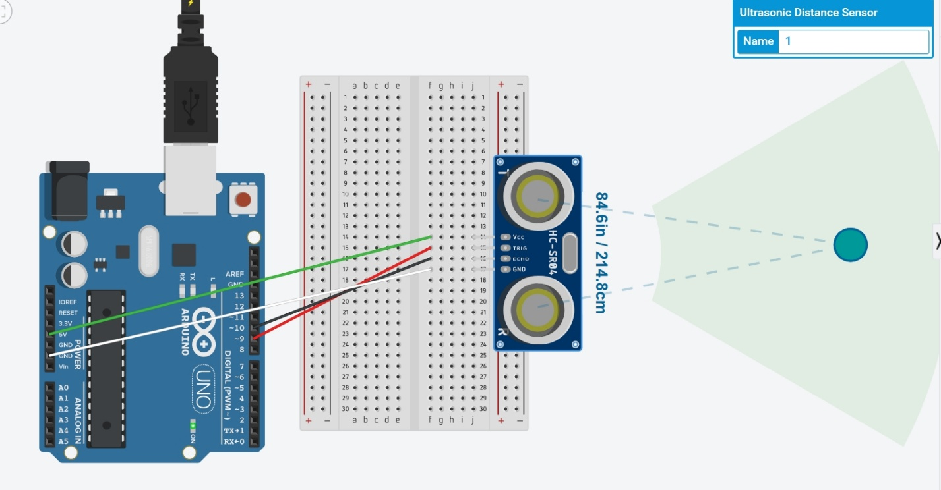

**Theory:-**

Concept Used:

* The Ultrasonic Sensors use sound waves to bounce off the objects in front of them . The proximity sensor send outs a signal and measures how long it takes to return.
* Then the Arduino program receives this information and calculated the distance between the sensor and object.
* Whenever sensor detects a object count number is increased.

Learning & Observations:

* I learned how to use A Ultrasonic Sensor and connect it with Arduino using breadboard.
* I learned about how Ultrasonic Sensor can be used in various real life situations.
* Whenever a person passes by the sensor it detects it and count number is increased .

Problems & Troubleshooting:

* There was problem while uploading code to Arduino , as the port selected was incorrect hence, to solve it I change the PORT.
* The sensor was not detecting the object as there was error in code . So, code was debugged.

Precautions:

* Arduino Board should be kept at dry place.
* Correct Board/Port is to be selected.
* All connections should be tight.
* No objects should be placed in front of sensor.
* The Trigger pin should be connected with pin as Output mode.
* The Echo pin should be connected with pin as Input Mode.

Learning Outcomes:

* How the waves are sent and received by sensor when object is detected.
* Whenever person passes by The waves are bounced back and the whole time taken is T whereas to reach the object it is t/2.
* Learnt how to make connections between sensor and Arduino using breadboard.